PERSONAL NOTES WEB APP USING AWS
Prepared in the partial fulfillment of the Summer Internship Program on AWS
AT

Under the guidance of
Mrs. Sumana Bethala, APSSDC
Mr. Rama Krishna, APSSDC
Submitted by (Batch-97)
Kusu Bhavani(23P31A42H1)
Rayudu Saritha(23P31A42I3)
Kovvuri Harini Jyothsna(23MH1A4298)
Batta MouniSree(23MH1A4274)
Goluguri Aishwarya Reddy(23MH1A4286)

ACKNOWLEDGEMENT

I would like to express my heartfelt gratitude to all those who have contributed to the successful
completion of my summer internship project at Andhra Pradesh Skill Development
Corporation (APSSDC). This opportunity has been an enriching and transformative
experience for me, and I am truly thankful for the support, guidance, and encouragement I have
received along the way.

First and foremost, I extend my sincere regards to Mrs Sumana Bethala and Mr Rama Krishna,
my supervisors and mentors, for providing me with valuable insights, constant guidance, and
unwavering support throughout the duration of the internship. Their expertise and
encouragement have been instrumental in shaping the direction of this project.

I would like to thank the entire team at Andhra Pradesh Skill Development Corporation
(APSSDC) for fostering a collaborative and innovative environment. The camaraderie,
knowledge sharing, and feedback I received from my colleagues significantly contributed to
the development and success of this project.

In conclusion, I am honoured to have been a part of this internship program, and I look forward
to leveraging the skills and knowledge gained to contribute positively to future endeavours.

Thank you.
Sincerely,
ABSTRACT

The Personal Notes Web App is a cloud-based application designed to help users create, manage,
and access their personal notes securely from any device. Developed using Amazon Web
Services (AWS), the application leverages various cloud services to ensure scalability, high
availability, and robust security.
This project aims to provide a user-friendly interface for note-taking with features such as user
authentication, note categorization, search functionality, and real-time syncing. AWS services
such as Amazon S3 for storage, Amazon DynamoDB or RDS for database management, AWS
Lambda for serverless backend functions, and Amazon Cognito for user authentication are
utilized to deliver a seamless and responsive experience.
The application architecture follows modern web development practices, with a front-end built
using HTML, CSS, and JavaScript (or a framework like React), and backend services integrated
through API Gateway and Lambda. The system ensures data persistence, user privacy, and real-
time performance, making it suitable for students, professionals, and anyone needing a reliable
note-taking platform.
This project demonstrates the practical application of cloud computing principles, especially
serverless architecture, and highlights how AWS can be effectively used to build and deploy
scalable web applications with minimal infrastructure management.

TABLE OF CONTENTS
S.No Content Pg.No
1. Introduction………………………………………………………………………………. 5
2. Methodology……………………………………………………………………………... 7
3. System Design / Architecture…………………………………………………………….. 9
4. Implementation……………………………………………………………………………. 12
5. Results…………………………………………………………………………………….. 15
6. Conclusion……………………………………………………………………………….. 21

- INTRODUCTION

With the rapid growth of cloud computing and the increasing demand for digital productivity
tools web-based note-taking applications have become essential for both personal and
professional use. Users expect secure, reliable, and cross-platform access to their notes
anytime and anywhere. Traditional server-based applications often face challenges related to
scalability, high maintenance costs, and limited fault tolerance. To overcome these
limitations, the Personal Notes Web App has been developed as a cloud-native, serverless
solution leveraging Amazon Web Services (AWS).
This project aims to build a responsive and efficient web application that enables users to
create, edit, delete, and manage personal notes through a secure interface. The application is
architected entirely on AWS using managed services, ensuring minimal infrastructure
overhead, maximum scalability, and cost-effective operation. The use of a serverless
architecture allows backend code to be executed only when needed, reducing unnecessary
resource consumption.
Key AWS Services Used
- Amazon Cognito: Provides secure user sign-up, sign-in, and access control. It ensures that only authenticated users can access and manage their personal notes.
- AWS Lambda: Acts as the serverless compute engine to run backend logic in response to API requests. It eliminates the need to maintain or provision servers.
- Amazon API Gateway: Facilitates communication between the frontend and the backend by exposing RESTful APIs that trigger Lambda functions.
- Amazon DynamoDB: Serves as the primary NoSQL database for storing user-generated notes. It offers high-speed read/write operations and automatic scaling.
- Amazon S3: Hosts the static frontend assets (HTML, CSS, JS) and optionally stores user-uploaded files or attachments associated with notes.
Architecture Overview
The architecture follows a modular and loosely-coupled design. The frontend is built using
standard web technologies (or optionally with frameworks like React or Vue.js) and hosted
on Amazon S3 as a static website. When a user interacts with the app, such as creating or
retrieving notes, the frontend sends API requests to Amazon API Gateway. These requests are
routed to AWS Lambda functions, which handle business logic such as CRUD operations.
The Lambda functions interact with DynamoDB to store or fetch notes data. User
authentication and session management are handled seamlessly by Amazon Cognito.
This setup ensures:
- High availability through distributed AWS services.
- Scalability through DynamoDB’s on-demand capacity and Lambda’s event-driven nature.
- Security through Cognito-managed authentication tokens and HTTPS APIs.
- Cost-efficiency by using pay-per-use serverless resources.

2.METHODOLOGY

The development of the Personal Notes Web App using AWS followed a modular and iterative
methodology, aligned with modern cloud-native application development principles. The
entire process was divided into several key stages: requirement analysis, system design,
development, integration, testing, and deployment. The application leverages AWS serverless
architecture to ensure scalability, performance, and minimal infrastructure management.
1. Requirement Analysis
The first step involved identifying the core functionalities needed for a personal note-taking
application:
- User authentication and authorization
- Create, read, update, delete (CRUD) notes
- Cloud-based storage and access
- Responsive and user-friendly interface
Technical feasibility and cost-efficiency were also evaluated, leading to the decision to adopt
a serverless architecture using AWS services.
2. System Design
The architecture was designed to decouple the frontend and backend using RESTful APIs.
Key design choices included:
- Amazon Cognito for secure user management
- Amazon API Gateway for creating and managing REST APIs
- AWS Lambda for serverless execution of backend logic
- Amazon DynamoDB for storing user notes in a scalable NoSQL database
- Amazon S3 for hosting the frontend and storing static content
Each component was designed to interact via event-driven or HTTP-based triggers, ensuring
modularity and fault tolerance.
3. Frontend Development
The frontend was developed using standard web technologies (HTML, CSS, JavaScript) with
the goal of keeping it lightweight and responsive. JavaScript was used to call the backend
APIs and manage authentication tokens locally using Amazon Cognito.
4. Backend Development
Backend functionality was implemented using AWS Lambda functions, written in Node.js.
Each function corresponds to a specific operation:
- createNote: Add a new note to DynamoDB
- getNotes: Retrieve all notes for a user
- updateNote: Modify an existing note
- deleteNote: Remove a note from the database
These functions were integrated with API Gateway to expose secure, authenticated endpoints.
5. Authentication Integration
Amazon Cognito was configured to manage user pools and generate JWT tokens. These
tokens were validated via an API Gateway authorizer to ensure that only authenticated users
could access the API.
6. Database Integration
DynamoDB tables were created with partition and sort keys (userId, noteId) to efficiently
store and query notes per user. Indexing and timestamps were used to support sorting and
retrieval.
7. Hosting and Deployment
The static frontend files were uploaded to an S3 bucket and hosted as a static website. API
Gateway and Lambda were connected via stages (e.g., /dev) and tested using tools like
Postman.
Deployment was managed manually via the AWS Console, with plans for automation using
AWS SAM or GitHub Actions in the future.
8. Testing and Validation
Each module was unit-tested independently. Integration testing was conducted using:
- Postman for API validation
- Browser-based testing for UI functionality
- AWS CloudWatch for logging and error tracing
Security was verified through token validation and access control.

3.SYSTEM DESIGN / ARCHITECTURE

The architecture of the Personal Notes Web Application follows a layered approach using
cloud-native services provided by Amazon Web Services (AWS). This modular architecture
enhances scalability, security, and maintainability while reducing infrastructure management
through a fully serverless stack.
The system is logically divided into four main layers:
- Presentation Layer
- Application Logic Layer
- Data Storage Layer
- Cloud Hosting & Deployment

1. Presentation Layer
This layer serves as the front-end interface that interacts directly with the user. It is developed
using HTML, CSS, and JavaScript and is hosted on Amazon S3 as a static website.
Key Features:
- User Interface: Web-based interface for login, registration, and note management (CRUD operations).
- Authentication: Integrates with Amazon Cognito for secure user sign-in/sign-up.
- Token Handling: Retrieves and stores JSON Web Tokens (JWT) for authenticated API access.
- API Requests: Communicates with backend APIs using fetch() or similar libraries.
- Responsiveness: Designed to be responsive across mobile and desktop devices.

2. Application Logic Layer
This layer handles business logic and processes requests from the frontend. It is implemented
using AWS Lambda functions, which are stateless and serverless, and exposed via Amazon
API Gateway.
Components and Responsibilities:
- AWS API Gateway: Accepts and routes HTTP requests to Lambda functions.
- AWS Lambda Functions:
  - createNote: Adds a new note for a user.
  - getNotes: Retrieves all notes associated with a user.
  - updateNote: Edits a user’s existing note.
  - deleteNote: Deletes a specific note.
- Amazon Cognito Authorizer: Verifies JWT tokens and restricts access to authenticated users only.
This design ensures that each function remains focused, lightweight, and independently
scalable.

3. Data Storage Layer
All user-generated data, primarily personal notes, is stored in a secure and highly scalable
NoSQL database managed by AWS.
Primary Storage:
- Amazon DynamoDB:
  - Used to store note data.
  - Table schema includes:
    - userId (Partition Key)
    - noteId (Sort Key)
    - Attributes: title, content, timestamp
Optional Storage:
- Amazon S3 (Extended Use):
  - For storing image attachments or exporting notes.
  - Can also serve as a backup destination.
DynamoDB’s flexible schema, low-latency access, and serverless nature make it suitable for
this use case.

4. Cloud Hosting and Deployment
All application components are deployed using AWS’s managed services, ensuring fault
stolerance, automatic scaling, and minimal DevOps overhead.
Services Used:
- Amazon S3: Hosts the frontend as a static website.
- Amazon API Gateway: Manages RESTful API endpoints and enforces authorization via Cognito.
- AWS Lambda: Executes backend logic on-demand.
- Amazon Cognito: Handles user authentication and authorization.
- Amazon CloudWatch: Collects logs and metrics for monitoring Lambda and API performance.
Deployment Workflow:
- Upload frontend files to the S3 bucket.
- Deploy Lambda function code manually or via automation (e.g., GitHub Actions, AWS CLI).
- Configure and deploy API Gateway routes connected to Lambda functions.
- Secure the APIs with Cognito Authorizers and manage permissions with IAM roles.

4. IMPLEMENTATION
The implementation phase involved converting the architectural design into a working web
application by integrating various AWS services and front-end components. The application
was developed using a modular and serverless approach to ensure performance, scalability,
and maintainability. This section describes the step-by-step development process,
technologies used, and integration of AWS services.

1. Frontend Implementation
The frontend was built using standard web technologies: HTML, CSS, and JavaScript (or
optionally React for dynamic rendering). It provides a clean and intuitive user interface for
managing personal notes.
Key Features Implemented:
- User registration and login forms
- Secure storage and handling of JWT tokens from Cognito
- Note-taking interface with CRUD (Create, Read, Update, Delete) functionality
- Asynchronous API calls using fetch() or Axios to communicate with the backend
- Responsive design compatible with desktops and mobile devices
Hosting:
- The frontend files were uploaded to an Amazon S3 bucket configured for static website hosting.
- Public read permissions were set, and bucket policy was updated to allow web access.
- Optional CloudFront distribution can be used to cache and deliver content globally.

2. User Authentication using Amazon Cognito
User authentication was implemented using Amazon Cognito, which provides secure user
sign-up, sign-in, and session management.
Steps:
- Created a Cognito User Pool to manage users.
- Configured app clients to handle token-based authentication.
- Integrated frontend with Cognito SDK to:
  - Register new users
  - Authenticate users and retrieve ID, Access, and Refresh Tokens
- These tokens are included in HTTP headers for secure API requests.

3. Backend Implementation using AWS Lambda & API Gateway
The backend logic was implemented using AWS Lambda functions triggered by Amazon API
Gateway. Each Lambda function performs one specific operation on the database.
Lambda Functions Implemented:
- createNote(): Stores a new note for the authenticated user
- getNotes(): Retrieves all notes for the current user
- updateNote(): Updates an existing note identified by its ID
- deleteNote(): Deletes a specific note
API Gateway Configuration:
- REST APIs were created for each endpoint (/create, /get, /update, /delete)
- Attached Cognito Authorizer to validate JWT tokens from the frontend
- Enabled CORS for cross-origin frontend access
Languages Used: Node.js (or Python) for Lambda functions
Development Tools: AWS Console, AWS CLI, Postman (for testing)

4. Data Storage using Amazon DynamoDB
A DynamoDB table was created to store notes efficiently using a NoSQL schema. The table
design supports fast lookups and scalable access.
Table Schema:
- Partition Key: userId (from Cognito token)
- Sort Key: noteId (unique identifier for each note)
- Attributes: title, content, timestamp, tags (optional)
Access Control:
- Lambda functions use IAM roles with permission to perform PutItem, GetItem, UpdateItem, and DeleteItem on the table.
- All access is scoped to the authenticated user only.

5. Cloud Hosting & Deployment
Deployment Steps:
- Frontend Deployment:
  - Build static files and upload them to an S3 bucket.
  - Configure bucket for static website hosting.
- Backend Deployment:
  - Create and test Lambda functions via AWS Console or CLI.
  - Set up API Gateway routes and connect them to Lambda.
  - Use Cognito Authorizers on secured endpoints.
- Monitoring:
  - Enabled AWS CloudWatch logs for Lambda and API Gateway to monitor usage, errors, and performance.
- Security:
  - IAM policies were created to ensure principle of least privilege.
  - All APIs are protected by Cognito JWT token validation.

6. Testing
Testing was performed at multiple levels:
- Unit Testing: Individual Lambda functions were tested using mock data.
- Integration Testing: API Gateway and Cognito integration were validated using Postman.
- End-to-End Testing: Full user flow tested via browser (register → login → create → view → update → delete notes).

5.RESULTS
The Personal Notes Web Application was successfully developed and deployed using AWS
services. The final product is a functional, user-friendly, and secure cloud-based platform that
enables users to create, view, update, and delete their personal notes from any device with
internet access.

Functional Outcomes
The application met all major functional requirements as designed. The following key
features were successfully implemented and tested:
Feature | Result | Status
User Registration & Login | Successfully managed via Amazon Cognito | Completed
Create Note | New notes are saved and displayed | Completed
Read Notes | User can view all saved notes | Completed
Update Note | Edits to note content are saved | Completed
Delete Note | Selected note is removed from the database | Completed
Authentication & Authorization | JWT-based access enforced for all APIs | Completed
Responsive Web Interface | Mobile/tablet/desktop compatible | Completed
Secure Cloud Storage (DynamoDB) | Data stored securely per user | Completed
Serverless Deployment (Lambda/API) | Scalable backend without managing servers | Completed

Performance Results
- Scalability: Application scales automatically using AWS Lambda without needing manual intervention.
- Latency: API requests (read/write operations) returned responses within ~300ms to 1s.
- Data Integrity: Notes are user-isolated; users can only access their own notes.
- Security: Unauthorized access is blocked at the API Gateway using Cognito token validation.

Testing Summary
Test Type | Tools Used | Outcome
Unit Testing | Postman, Lambda test console | All functions returned expected results
Integration Testing | Browser, API Gateway | Full user flow worked correctly
Cross-browser Testing | Chrome, Firefox, Edge | Consistent UI/UX
Error Handling | Manual input testing | Errors displayed and logged correctly
Data Persistence | DynamoDB table view | Verified data after CRUD operations

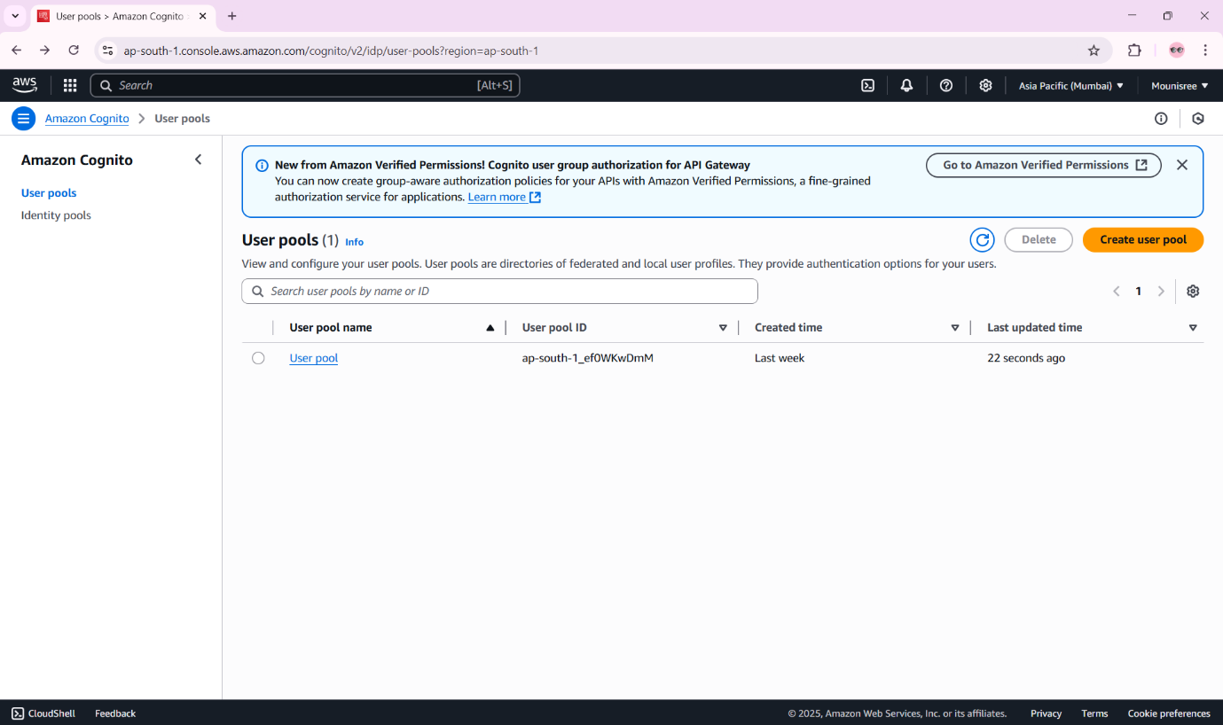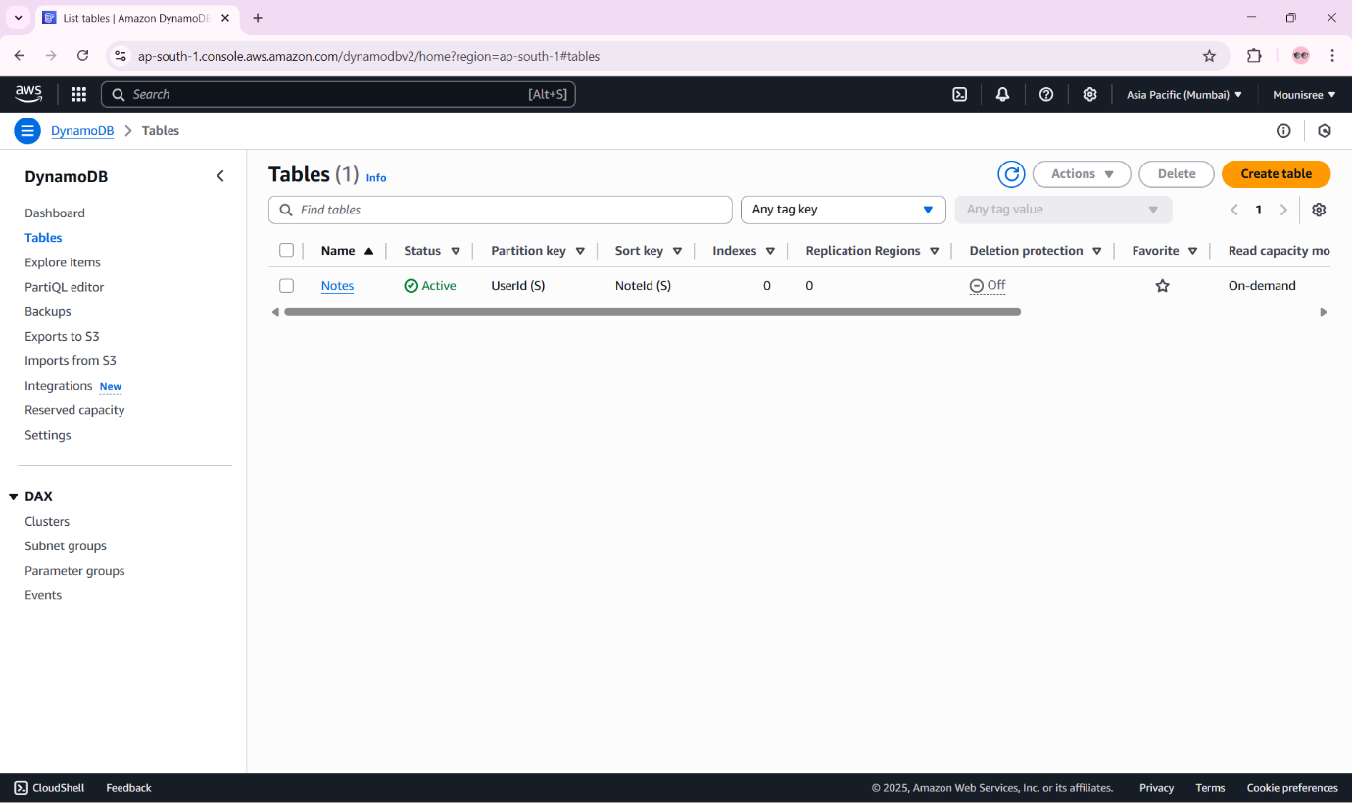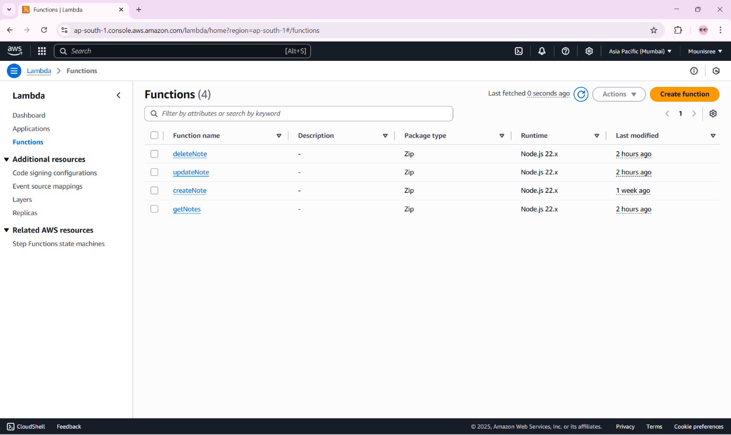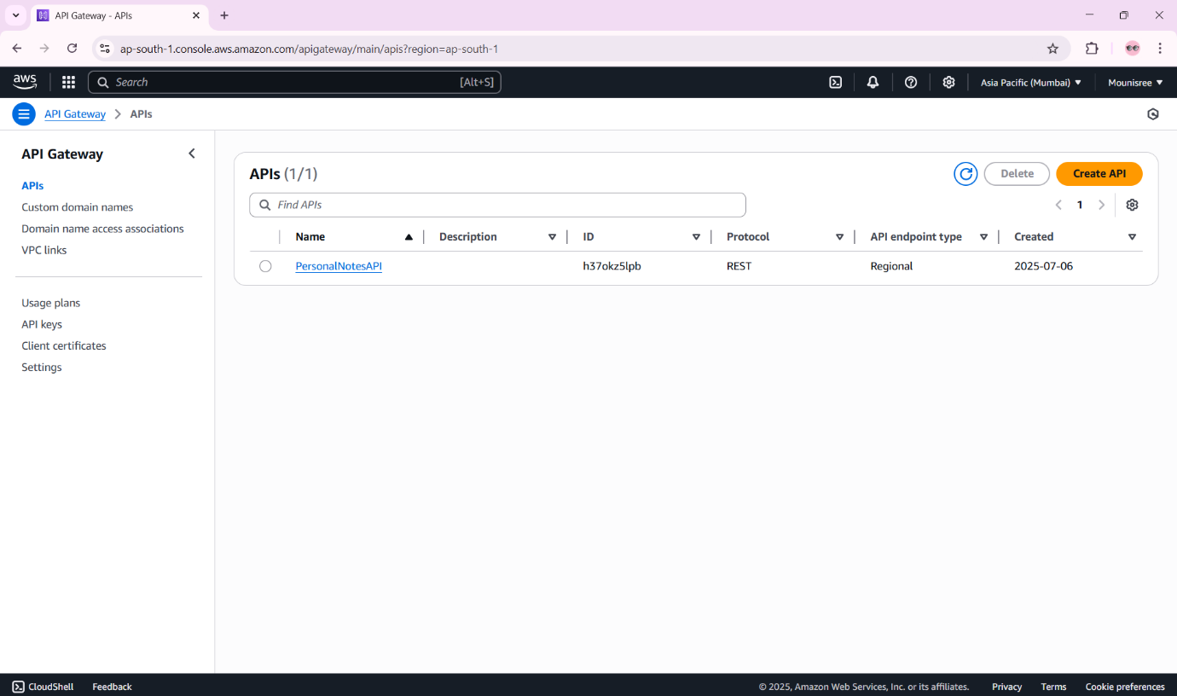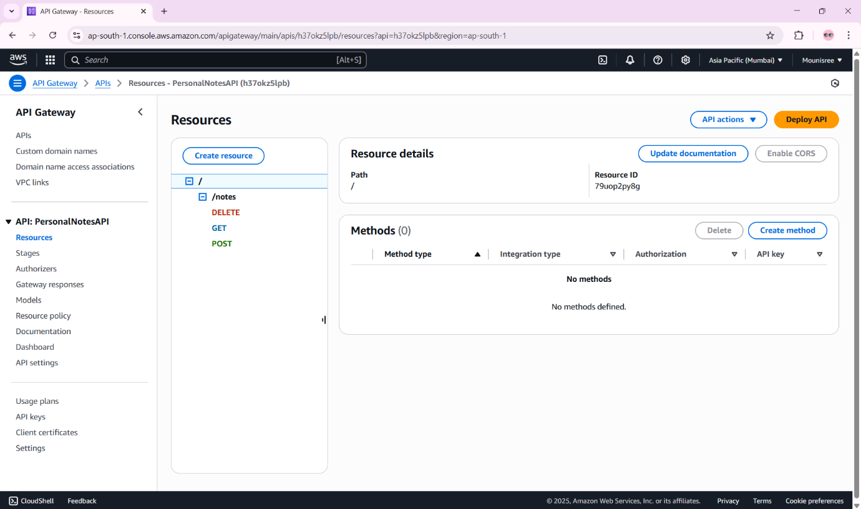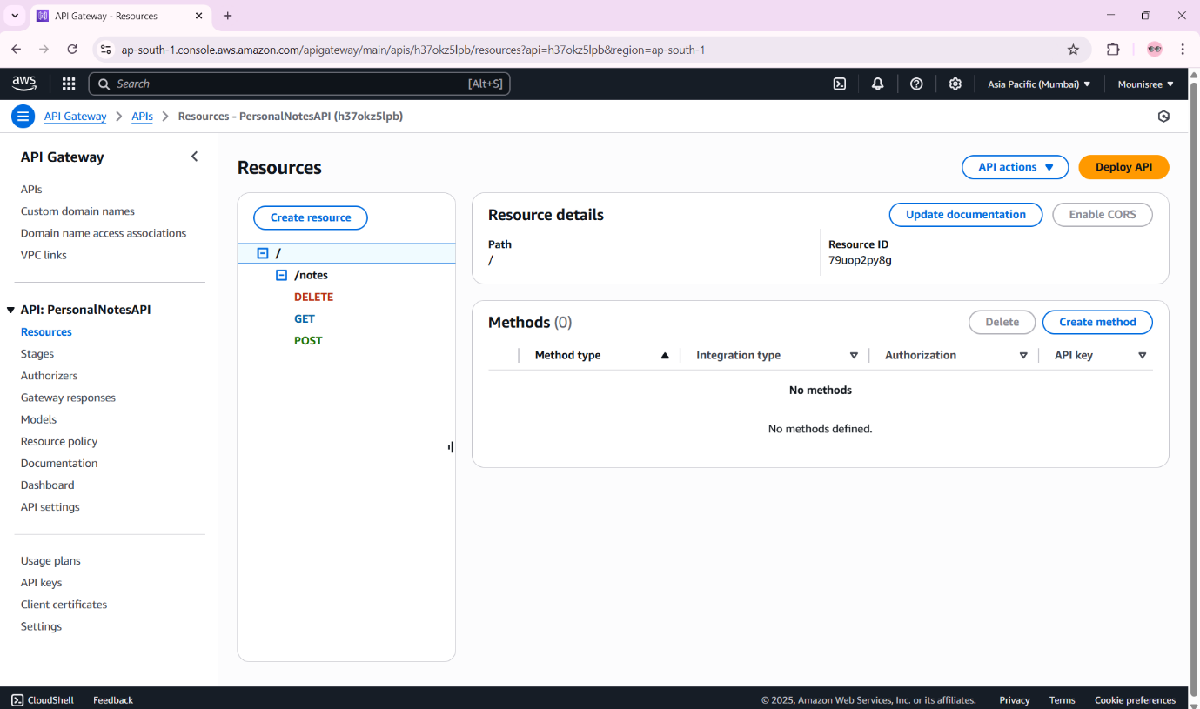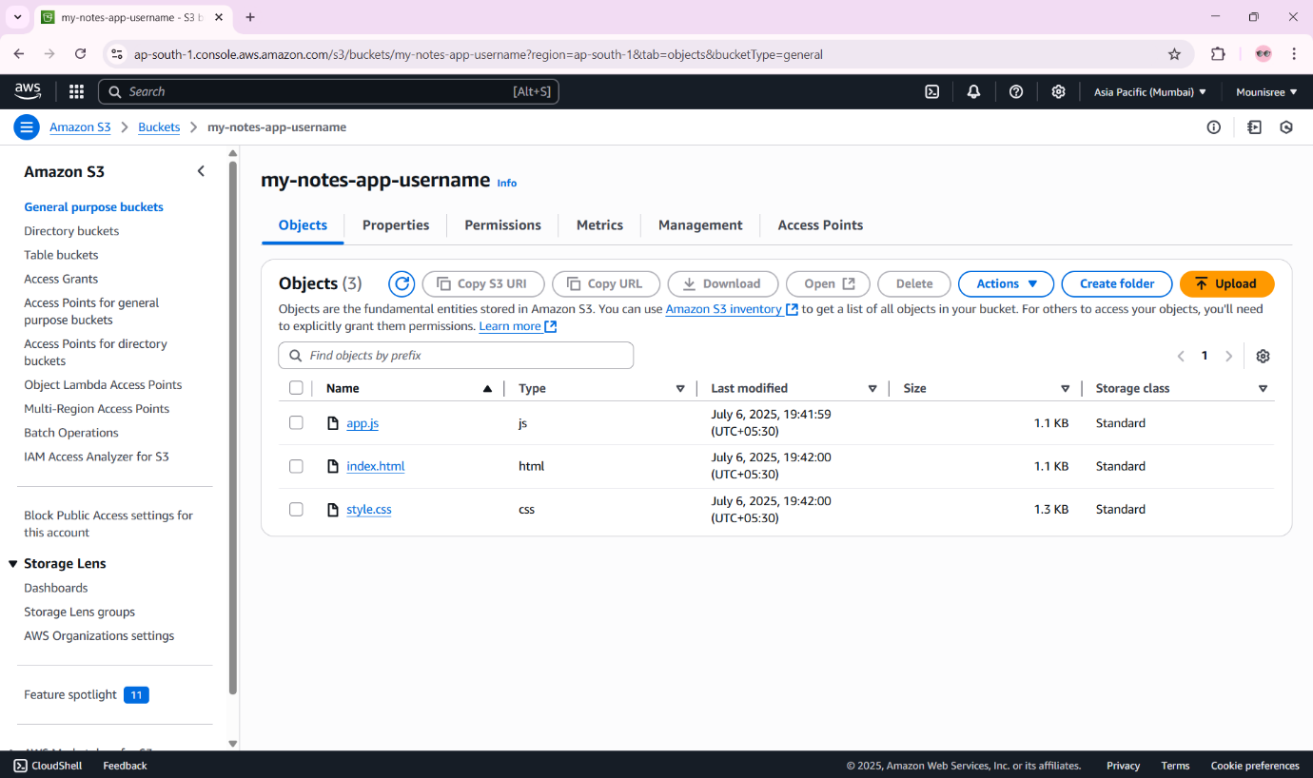

6.CONCLUSION
The Personal Notes Web Application using AWS demonstrates the practical application of
cloud-native technologies to solve a real-world problem—secure and accessible note
management. By adopting a serverless architecture, the project eliminates infrastructure
overhead while ensuring scalability, reliability, and performance.
The seamless integration of Amazon Cognito for authentication, API Gateway and Lambda
for backend logic, DynamoDB for persistent data storage, and S3 for frontend hosting results
in a fully functional, secure, and efficient system. Each service plays a distinct role in
ensuring that the application can grow with user demand while keeping operational
complexity low.
This project not only achieves its intended functionality but also highlights modern best
practices in web development and cloud deployment. It exemplifies how students and
developers can leverage AWS to build production-ready applications without managing
traditional servers or worrying about scalability concerns.
In conclusion, this application lays a strong foundation for future enhancements such as rich
text editing, file attachments, reminders, or cross-device syncing. It also serves as a valuable
learning experience in full-stack serverless development—a key skill in today’s software
industry.

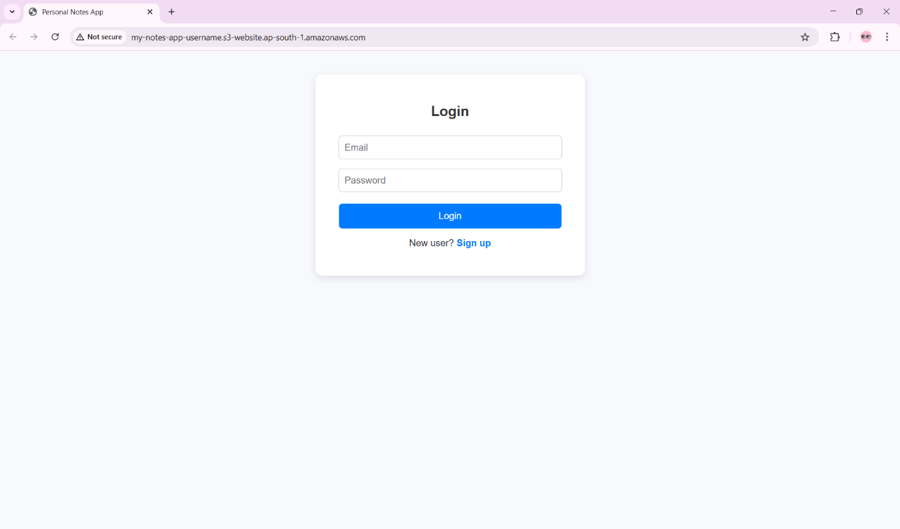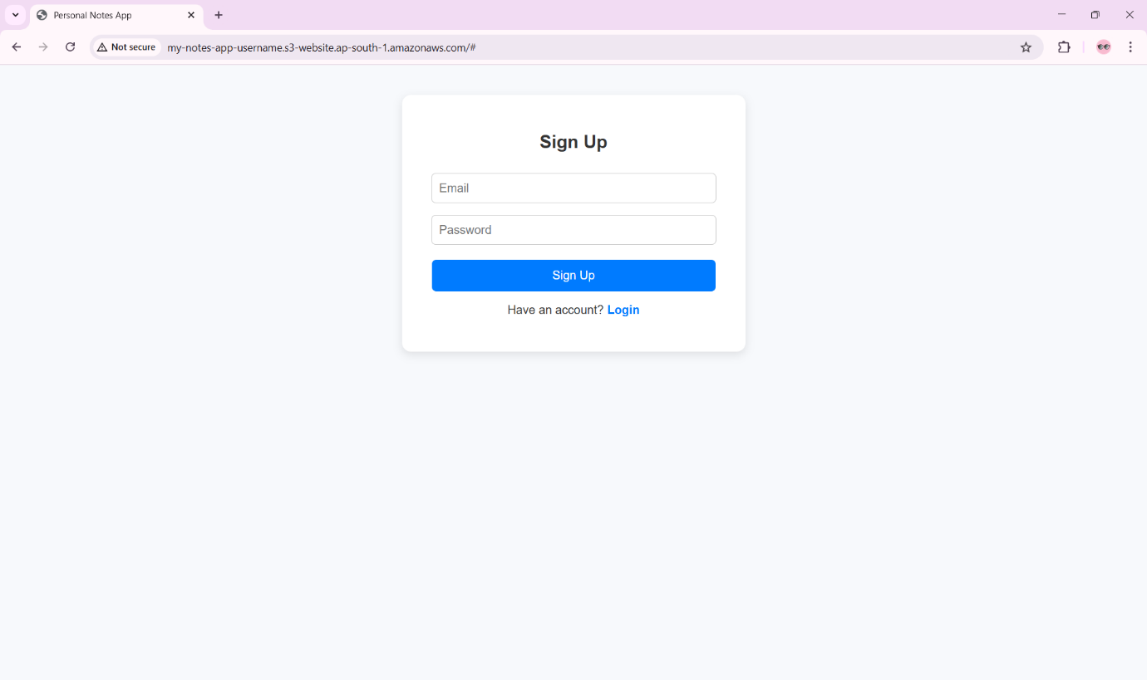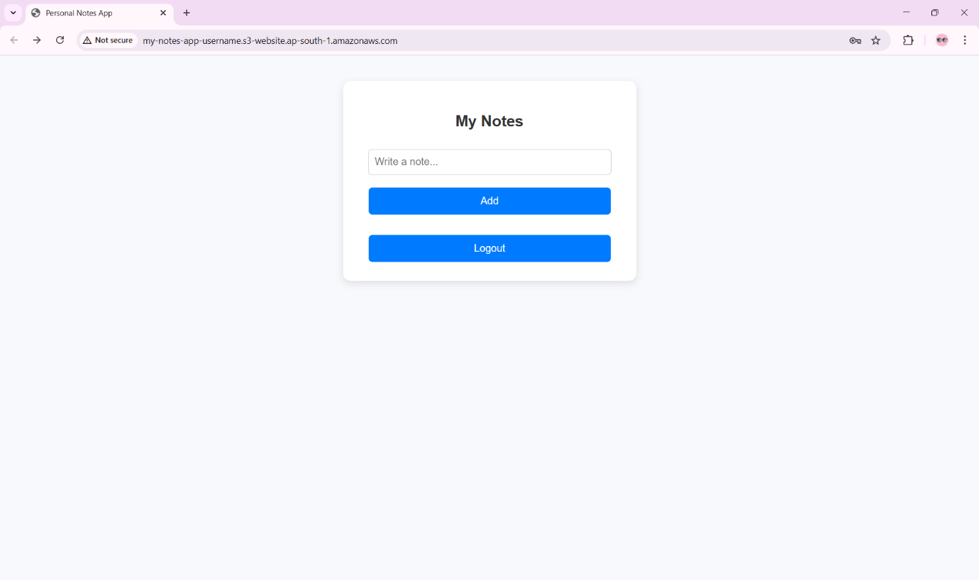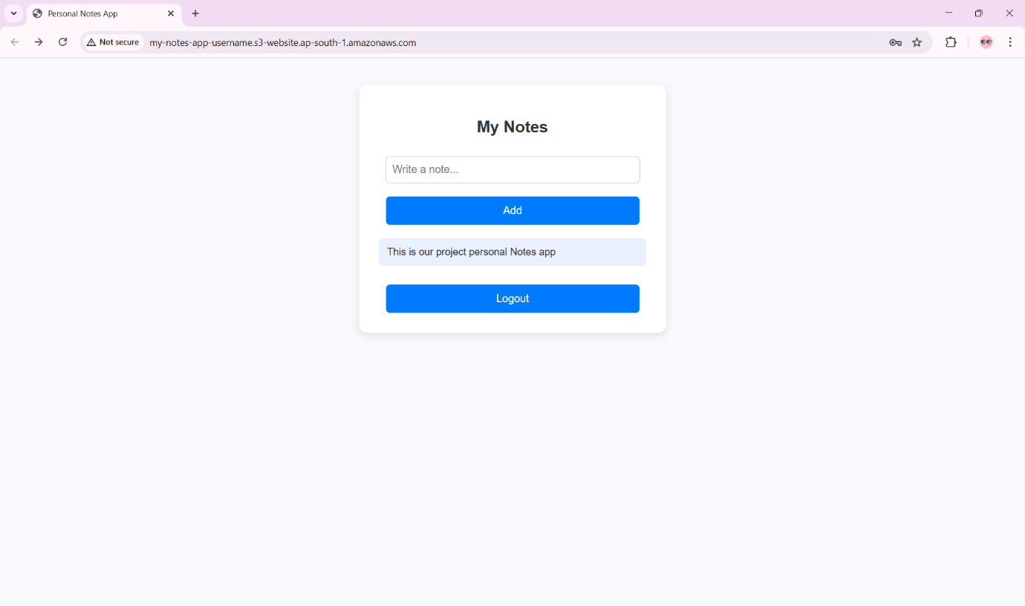

Demo link: https://drive.google.com/file/d/1i-rVbWRaBSQFvcBdvr5sPv6xkRRYOW16/view?usp=drivesdk

References
- Amazon Web Services (AWS). (2024). Amazon Simple Storage Service (S3) Documentation. Retrieved from https://docs.aws.amazon.com/s3/
- Amazon Web Services (AWS). (2024). AWS Lambda Developer Guide. Retrieved from https://docs.aws.amazon.com/lambda/
- Amazon Web Services (AWS). (2024). Amazon API Gateway Developer Guide. Retrieved from https://docs.aws.amazon.com/apigateway/
- Amazon Web Services (AWS). (2024). Amazon Cognito Developer Guide. Retrieved from https://docs.aws.amazon.com/cognito/
- Mozilla. (2024). MDN Web Docs – HTML, CSS, and JavaScript. Retrieved from https://developer.mozilla.org/
- W3Schools. (2024). Web Development Tutorials. Retrieved from https://www.w3schools.com/
- Open Web Application Security Project (OWASP). (2024). OWASP Top 10 Web Application Security Risks. Retrieved from https://owasp.org/www-project-top-ten/
- AWS Amplify Documentation. (2024). Frontend Integration and Deployment. Retrieved from https://docs.amplify.aws/

